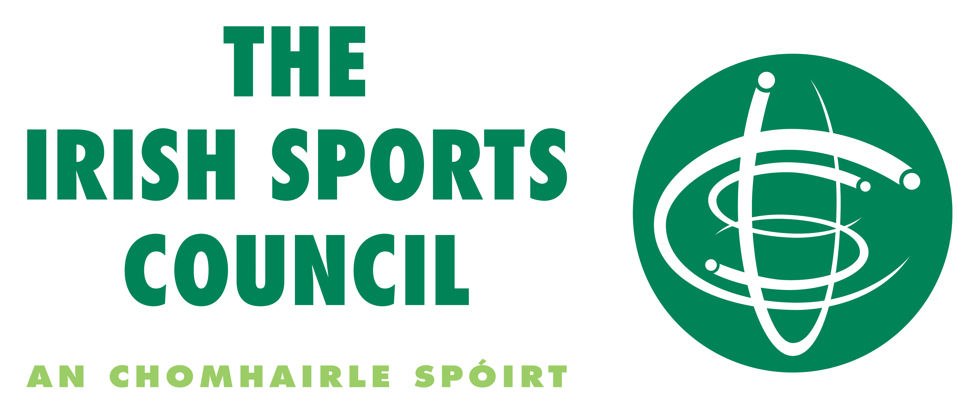
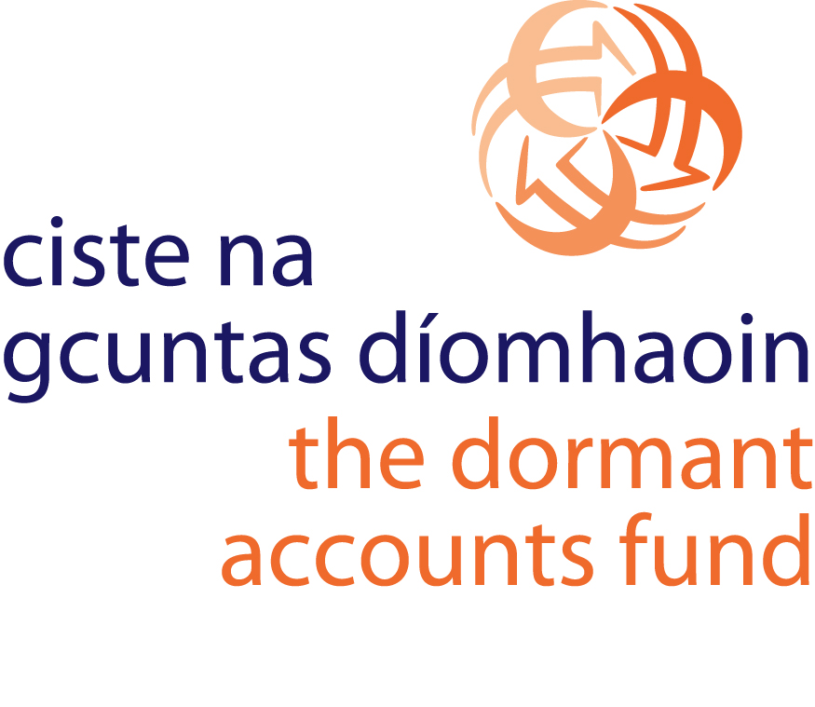
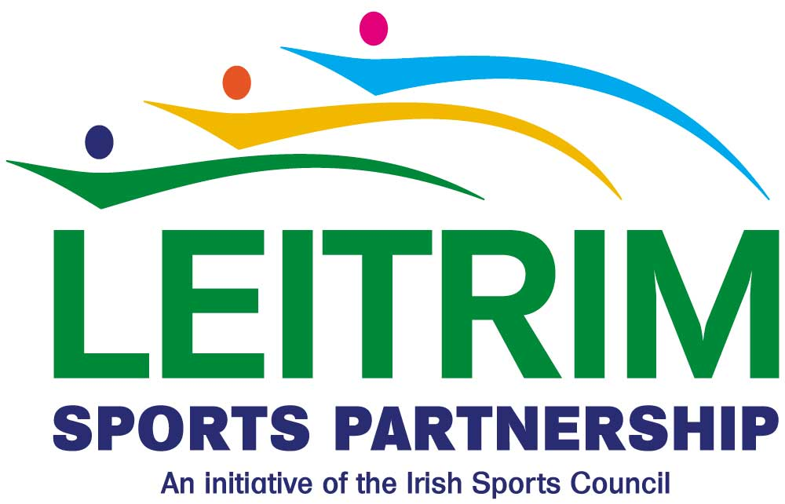



Have you got time to get a coaching qualification in Athletics, Rugby or Soccer?

Leitrim Sports Partnership in association with Leitrim County Council, Irish Sports Council, Dormant Accounts Fund, Department of Social Protection, Connacht Rugby (IRFU), the FAI and Athletics Ireland would like to invite applications from unemployed people who would have the time to commit to two days a week training to become a fully qualified athletics, soccer and rugby coaches. The programme is open to men and women who can see the potential in becoming a part time or full time coach. Potential participants may be entitled to retain their social welfare payments subject to certain conditions.

“Community Coaching Programme” is an exciting new initiative developed in 2009 piloted by Leitrim County Council. While an interest in sport is desirable, it is not essential as full training on rugby, soccer and athletics coaching skills as well as child protection, Occupational first aid and motivational skills is included. In addition, Leitrim County Enterprise Board will provide a module on how to explore setting up your own business, marketing and presentation skills. All of which would help participants to identify possible employment opportunities after the 12 week programme.

According to Declan Boyle, Sports Coordinator of Leitrim Sports Partnership the focus of “Community Coaching programme” will be to tutor people as coaches with the aim of providing them with an option of setting up on a self-employed basis or to encourage the participants into sport and recreational career at the end of the coaching period.

The programme will consist of a 12 week course starting in September operating for two days a week. The course will include one day coaching training and one day of ancillary training in the above mentioned areas. The coaching training will take place in the schools, community and youth groups and the ancillary training will take place in the offices of Leitrim County Council. The added benefit would be the availability of an increased number of coaches to work with the various schools, clubs and youth groups across a number of sports.

Councillor, Enda Stenson Chairperson of the Leitrim Sports Partnership said “This unique programme has been made possible through agencies working together. The partnership with the Leitrim Sports Partnership, Leitrim County Council, Irish Sports Council, Dormant Accounts Fund, Leitrim Enterprise Board, Connacht Rugby, the FAI, Athletics Ireland and the Dept of Social Protection has been the key to the success of this programme”. He then went on to say “We have had fabulous support from the sporting bodies and the all the Agencies and like the previous programme there will be no doubt some amazing success stories from the programme. Rugby, Soccer and Athletics are all sports that are easy to play and appeal to people of all ages and different walks of life”.

If you want to find out more about this highly innovative initiative come along to the open evening in Leitrim County Council offices on Monday, September 7th at 7pm. Application forms will be available on the evening. Places will be limited to twelve so if you would like to apply for this programme please contact Leitrim Sports Partnership on 071 9650498 or email sports@leitrimcoco.ie before Friday 4th September.


