

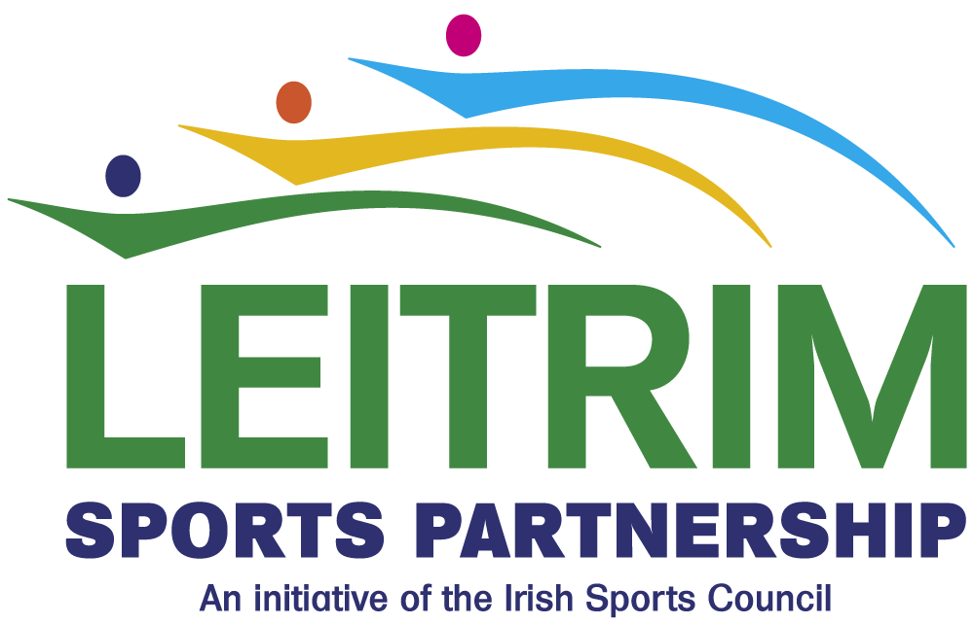

Invite to Tender
For
“Community Coaching Training Programme”

Leitrim Sports Partnership provides a management role for the coordination, development and delivery of sport and recreational activity for the collective benefit of the people and communities of Leitrim. The core purpose of the Leitrim Sports Partnership is to promote greater participation in sport and recreational activities within our planned target groups.

We are now seeking tenders for the delivery of the “Community Coaching Programme” sports coach training programme in Carrick on Shannon, Co. Leitrim. This training programme will be delivered by Leitrim Sport Partnership in partnership with the Irish Sports Council under the Dormant Account Grant Scheme.

Tender Details
This tender is for the co-ordination of the entire training programme and delivery of the classroom learning element of the Community Coaching programme at Leitrim County Council offices, Carrick on Shannon and is for 2 days per week for 14 weeks course which is aimed at assisting 12 unemployed people from Leitrim area to train as a Soccer/Athletics/Rugby Coach so that they may gain employment within their chosen discipline. One day each week will be classroom based while the second day will be based within disability, schools, community and youth club settings with the support of the Development Officers within the FAI, Athletics and Connaught Rugby who will have responsibility for tutoring the Practical Coaching Components of the Community Coaching Programme.

Location | Leitrim County Council Offices
Training Course | Community Coaching Training Programme
Proposed Start Date | Monday 14th September
Duration | 2 days per week x 14 Weeks 9.30 a.m. until 4.30pm with a number of additional days (max. 6)
Proposed Finish Date | Monday 14th December
Number of Participants | 12
Closing Date For Receipt of Proposal | Friday August 28th @4.00pm

The Community Coaching training programme will include a classroom based learning component with modules in Business and career planning and the successful tenderer must be able to manage this training schedule. It will also deliver accredited training in Occupational First Aid, Child Protection in Sport, Irish Sports Council Active Leadership Award and Disability Inclusion Training and these components will be delivered by specialist facilitators. The successful tender will not incur associated costs for the delivery of these additional components. In addition to these accredited modules this training programme will also provide information through specialist guest speakers on how to set up and manage your own business, enterprise opportunities, job readiness skills, personal development, building self esteem and self confidence, identification of personal progression options in employment, further education and training. The successful tenderer will have responsibility for the identification of such guest speakers and arranging the schedule of speakers. The successful tenderer will also have responsibility for recruiting participants for the programme and for providing evaluation of the progamme at its conclusion.

Budget
A maximum budget of €5000 (Inclusive of VAT and all other expenses) has been allocated for the above piece of work.
The successful tenderer will contract with Leitrim Sports Partnership as Lead Partner. The main point of contact will be Declan Boyle, Leitrim Sports Partnership.

Project Timeframe
The timeframe for the project is from September to December 2015
This Project will be launched in early September 2015.

Freedom of Information
Tenders should be aware that, under the Freedom of Information Acts 1997 and 2003, information provided by them during this public procurement competition may be liable to be disclosed.

Tenderers are asked to consider if any of the information supplied by them in their Tender should not be disclosed because of its commercial sensitivity. If Tenders consider that certain information is not to be disclosed because of its commercial sensitivity, tenders should, when providing such information, clearly identify same and specify the reasons for its commercial sensitivity. If Tenderers do not identity it as commercially sensitive, it is liable to be released in response to a Freedom of Information request without further consultation with you. The Contracting Authority will, where possible consult with Tenderers about commercially sensitive information so identified before making a decision on a request received under the Freedom of Information Acts.

Insurances
The successful Tenderer shall effect and maintain insurance (Public Liability (€2.5m) and Employers Liability) necessary to cover their liabilities under this contract. The successful tenderer must indemnify Leitrim County Council. Evidence of this is to be forwarded one week from date of signing contract and must be valid when each invoice is being made.

Tender Procedure
A tender document must be submitted which must include a project delivery plan which in addition must identify the methods deployed that will achieve the outputs identified for the actions associated with this tender. The tender document is to be laid out as per the headings underneath.

Tenderers must provide the following information:-
- Provision of Personal Profile and relevant information outlining experience and suitability to undertake the tender;
- Tender/Price/Value for Money - If you are a company or individual applying from Northern Ireland, VAT at the Irish rate has to be paid by Leitrim County Council. Therefore your price will have to take into account the Irish VAT rate and reference to this should be made in your tender document. A detailed breakdown of the cost structure for the action is required. The quotation should also detail clearly the level of input and amount of time you will devote to the project on a weekly basis. You should also include ‘unit’ or ‘day’ rates, which you have used in calculating the costs.
- Knowledge and Understanding of the Brief - Tendering persons/organisations should demonstrate in their proposals a good understanding of the brief.
- Approach/Methodology - Your interpretation of how the requirements set out in the specification can best be met. Tenderers should provide any other information which is relevant.

Assessment of Tenders
Tenders will be assessed on the following criteria:
Criteria | Marks %
Technical competence of personnel proposed | 30%
Ideas presented to achieve the best outcomes for the project | 30%
Tender Price/Value for Money | 40%
Total Marks Available | 100%

Tenders must score a minimum of 65% threshold to qualify. Please note that the budget is €5000 (Inclusive of VAT and all other expenses).

Submissions

Please refer to the following items in relation to the acceptance of tenders:

- Any tender received after the closing date/time will NOT be accepted in any circumstances.
- Incomplete tenders WILL NOT be accepted in any circumstances.
- The Tenderer is fully responsible for the safe and timely delivery of their Tender.

Tendering organisations should seek to clarify any points of doubt or difficulty relating to the tender documentation before submitting their tender. Please contact Declan Boyle by email at dboyle@leitrimcoco.ie should you require clarification. No clarifications will be given after August 26th 2015.

Please e-mail submissions to sports@leitrimcoco.ie; in addition send 3 hard copies of the sumbssion
to:

Leitrim Sports Partnership, Aras an Chontae, Carrick on Shannon, Co. Leitrim
(Please quote “Community Coaching Training Programme”)

Closing Date is 4pm Friday 28th August 2015

Additional information can be obtained by contacting Leitrim Sports Partnership, 071 9650498/Email sports@leitrimcoco.ie

Leitrim Sports Partnership

Invite to Tender
For
Community Coaching Training Programme

This programme is based on the successful elements of the previously piloted ‘Goal to Work’ programme which was developed by a number of LSPs including Leitrim and Mayo LSP. Several other LSPs have run similar programmes and these LSPs have been involved in the consultation process to help design the programme. This programme is focused on successfully assisting unemployed people to gain employment, coaching, volunteering and further education opportunities in the sports sector for example as coaches, physical activity leaders etc. It will provide the participants with practical and theoretical sport-related skills and help them find relevant work experience in their local community. It also will contribute to the promotion of both physical and mental health amongst participants and in the community through the subsequent employment and/or volunteering work carried out by participants.

The programme will include a number of essential criteria, providing the delivery of specialised training and education courses for jobseekers. It will also include work experience opportunities in NGBs/Clubs/LSPs built in to the programme.

Aim: Delivery of specialised training and education courses for jobseekers

Objective:
    - Assist unemployed people to become qualified as coaches, referees, physical activity leaders etc
    - Improve the participants’ job prospects within the sports industry
    - Motivate participants to pursue the progression routes which have been identified as part of the programme (employment, coaching, volunteering, further education, etc)
    - Promotion of positive mental health through participation in sport; both for the participants themselves and in the communities in which they are based
    - Provision of coaching in disability, school, community and youth club settings
    - Provision of coaching in the sports where there are no full-time development officers
Programme Outline:

Tenderers should focus on the following themes:

Strand 1 Job Readiness Skills Development (includes Business Development)
Course focusing on CV writing, job seeking skills, IT skills, office skills, telephone skills, etc

Strand 2 Personal Development
Courses supporting the trainees to identify individual progression routes in terms of employment/self-employment, further education and training, coaching and volunteering, etc. Other aspects of personal development including confidence-building, leadership and language skills etc

Strand 3 Sports Coaching Training
The majority of coaching awards should be offered in sports where there are no full-time development officers within the county (local needs should be taken into account when choosing sports). The course can also include intros / tasters etc in Athletics/Soccer/ Rugby.

Strand 4 Physical Activity Training
Range of courses to be offered including for example Active Leadership Award, Child Protection Course, Disability Awareness Training, Occupational First Aid Certificate, Walking Leader, Fit4 Life, Go for Life PALs, etc

Strand 5 Job Placement Experience
A job placement programme (unpaid) must be incorporated into the course structure. The LSP can decide how to build in the work experience element. NGBs, LSPs, clubs, schools, community centres, etc can provide work experience opportunities to the participants on the course.

In addition to the above, all sports coaches will undergo Garda Vetting.

Tender Details
Tender documents should clearly outline the following:
- Organisation details, background information, capability statement, consultant’s CVs
- The personnel who will carry out each element of the project.
- Evidence of prior experience and track record in delivery of similar projects. Particular emphasis should be placed on experience of working with the community sector.
- Methodology to be used.
- Details of how the Community Coaching Programme will be evaluated
- The overall fee for the consultancy should be shown and should include the cost per day which will be charged, exclusive of VAT.

Additional supporting information can be included in appendices including samples of previous relevant work, together with client recommendations.

Before a contract is awarded, the successful contractor will be required to produce a valid, current Tax Clearance Certificate and a valid certificate of Professional Indemnity Insurance prior to commencement of the contract.

Persons who tender will not be entitled to claim any costs or expenses, which may be incurred in preparing their Tender whether or not it is successful.

Please note the venues will be organised by Leitrim Sports Partnership and all venue costs will be met.

Tender Evaluation Procedure
Tenders will be evaluated on the information provided at the time of tender. The successful applicant will be notified within a period of 2 weeks from closing date for receipt of tenders. Unsuccessful tenders will be notified when the appointment of the successful tender has been confirmed.

Specification
- Relevant Experience: Technical capacity, staff experience and qualifications.
- Track record and experience in delivering similar types of projects.
- Methodology
- Understanding of the brief
- Ability to deliver a results orientated programme promptly, efficiently and cost effectively
- Ability to complete the contract within 1 year from date of tender award.

Please enclose/attach:
- Project Delivery Plan
- Quotation for the proposed work

